Project Name :

8 –bit Adder

Project members:

Usama yazdani 20p-0598

Kashif Ali 20p-0648

Muzamil 20p-0108

Submitted to :

Sir Shakirullah Shah

Section :

BSCS-2D

Logically Diagram:



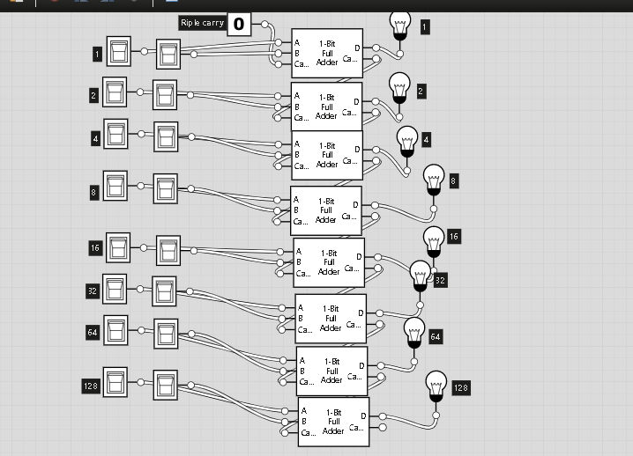

Explanation:

Here we use two half adder to make one full adder ic.

Then combine these ic to make 8 bit adder .

Questions About project:

In first ic, we also use simple half adder to make our project working properly .

Link of our video:

https://drive.google.com/file/d/1Pd7RrMrN1RgqkMJ3fhrgdGHKMtUYVVzg/view?usp=drive_web

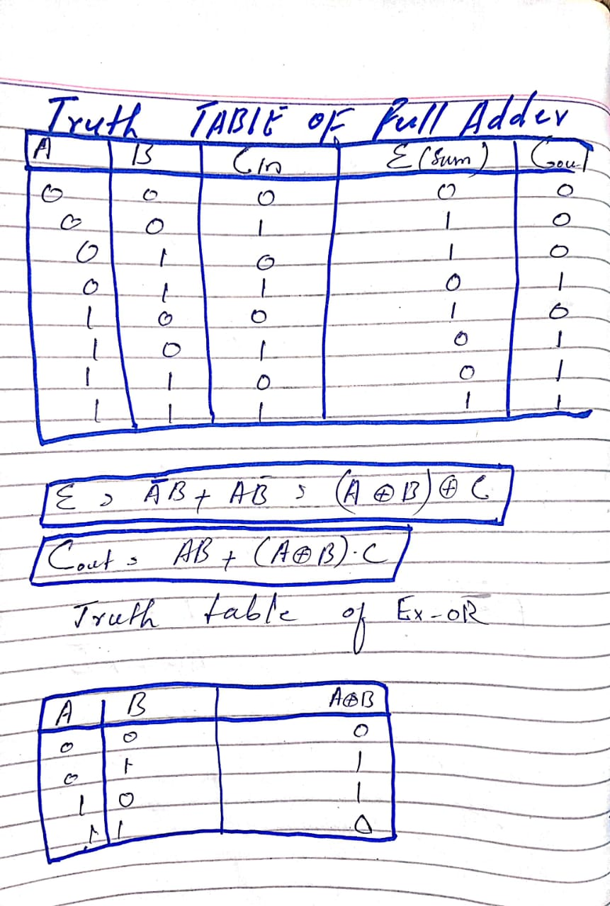

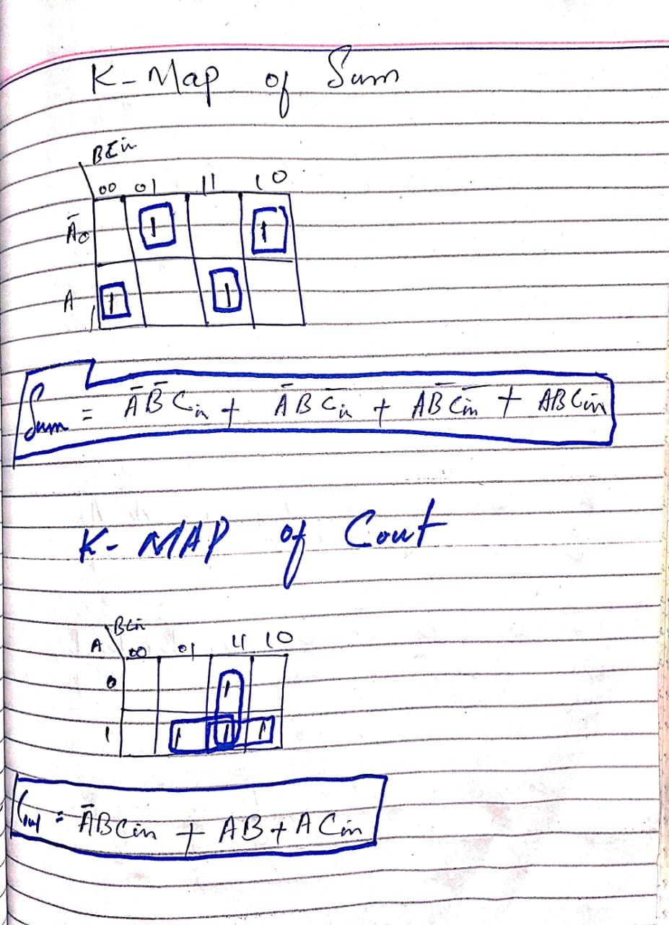

Truth Table :

|  |  |  |  |  |  |  |  |  |  |  |  |  |  |  |  |  |  |  |
| --- | --- | --- | --- | --- | --- | --- | --- | --- | --- | --- | --- | --- | --- | --- | --- | --- | --- | --- |
| a0 | a1 | a2 | a3 | a4 | a5 | a6 | a7 | b0 | b1 | b2 | b3 | b4 | b5 | b6 | b7 | cin | S | Cou |
| 0 | 0 | 0 | 0 | 0 | 0 | 0 | 0 | 0 | 0 | 0 | 0 | 0 | 0 | 0 | 0 | 0 | 0 | 0 |
| 0 | 0 | 0 | 0 | 0 | 0 | 0 | 0 | 0 | 0 | 0 | 0 | 0 | 0 | 0 | 1 | 0 | 1 | 0 |
| 0 | 0 | 0 | 0 | 0 | 0 | 0 | 0 | 0 | 0 | 0 | 0 | 0 | 0 | 1 | 0 | 0 | 0 | 0 |
| 0 | 0 | 0 | 0 | 0 | 0 | 0 | 0 | 0 | 0 | 0 | 0 | 0 | 0 | 1 | 1 | 0 | 0 | 0 |
| 0 | 0 | 0 | 0 | 0 | 0 | 0 | 0 | 0 | 0 | 0 | 0 | 0 | 1 | 0 | 0 | 0 | 0 | 0 |
| 0 | 0 | 0 | 0 | 0 | 0 | 0 | 0 | 0 | 0 | 0 | 0 | 0 | 1 | 0 | 1 | 0 | 1 | 0 |
| 0 | 0 | 0 | 0 | 0 | 0 | 0 | 0 | 0 | 0 | 0 | 0 | 0 | 1 | 1 | 0 | 0 | 0 | 0 |
| 0 | 0 | 0 | 0 | 0 | 0 | 0 | 0 | 0 | 0 | 0 | 0 | 0 | 1 | 1 | 1 | 0 | 1 | 0 |
| 0 | 0 | 0 | 0 | 0 | 0 | 0 | 0 | 0 | 0 | 0 | 0 | 0 | 0 | 0 | 0 | 0 | 0 | 0 |
| 0 | 0 | 0 | 0 | 0 | 0 | 0 | 0 | 0 | 0 | 0 | 0 | 0 | 0 | 0 | 1 | 0 | 1 | 0 |
| 0 | 0 | 0 | 0 | 0 | 0 | 0 | 0 | 0 | 0 | 0 | 0 | 0 | 0 | 1 | 0 | 0 | 0 | 0 |
| 0 | 0 | 0 | 0 | 0 | 0 | 0 | 0 | 0 | 0 | 0 | 0 | 0 | 0 | 1 | 1 | 0 | 1 | 0 |
| 0 | 0 | 0 | 0 | 0 | 0 | 0 | 0 | 0 | 0 | 0 | 0 | 1 | 1 | 0 | 1 | 0 | 1 | 0 |
| 0 | 0 | 0 | 0 | 0 | 0 | 0 | 0 | 0 | 0 | 0 | 0 | 1 | 1 | 0 | 0 | 0 | 0 | 1 |
| 0 | 0 | 0 | 0 | 0 | 0 | 0 | 0 | 0 | 0 | 0 | 0 | 1 | 1 | 1 | 1 | 0 | 1 | 1 |
| 0 | 0 | 0 | 0 | 0 | 0 | 0 | 0 | 0 | 0 | 0 | 0 | 1 | 1 | 1 | 0 | 0 | 0 | 1 |
| 0 | 0 | 0 | 0 | 0 | 0 | 0 | 0 | 0 | 0 | 0 | 0 | 1 | 0 | 0 | 1 | 0 | 1 | 1 |
| 0 | 0 | 0 | 0 | 0 | 0 | 0 | 0 | 0 | 0 | 0 | 0 | 1 | 0 | 0 | 0 | 0 | 1 | 1 |
| 0 | 0 | 0 | 0 | 0 | 0 | 0 | 0 | 0 | 0 | 0 | 0 | 1 | 0 | 1 | 1 | 0 | 1 | 1 |
| 0 | 0 | 0 | 0 | 0 | 0 | 0 | 0 | 0 | 0 | 0 | 0 | 1 | 0 | 1 | 0 | 0 | 1 | 1 |
| 0 | 0 | 0 | 0 | 0 | 0 | 0 | 0 | 0 | 0 | 0 | 0 | 0 | 1 | 0 | 1 | 0 | 1 | 1 |
| 0 | 0 | 0 | 0 | 0 | 0 | 0 | 0 | 0 | 0 | 0 | 0 | 0 | 1 | 0 | 0 | 0 | 1 | 1 |
| 0 | 0 | 0 | 0 | 0 | 0 | 0 | 0 | 0 | 0 | 0 | 0 | 0 | 1 | 1 | 1 | 0 | 1 | 1 |
| 0 | 0 | 0 | 0 | 0 | 0 | 0 | 0 | 0 | 0 | 0 | 0 | 0 | 1 | 1 | 0 | 0 | 1 | 1 |
| 0 | 0 | 0 | 0 | 0 | 0 | 0 | 0 | 0 | 0 | 0 | 0 | 0 | 0 | 0 | 1 | 0 | 1 | 1 |
| 0 | 0 | 0 | 0 | 0 | 0 | 0 | 0 | 0 | 0 | 0 | 0 | 0 | 0 | 0 | 0 | 0 | 1 | 1 |
| 0 | 0 | 0 | 0 | 0 | 0 | 0 | 0 | 0 | 0 | 0 | 0 | 0 | 0 | 1 | 1 | 0 | 1 | 1 |
| 0 | 0 | 0 | 0 | 0 | 0 | 0 | 0 | 0 | 0 | 0 | 0 | 0 | 0 | 1 | 0 | 0 | 1 | 1 |
| 0 | 0 | 0 | 0 | 0 | 0 | 0 | 0 | 0 | 0 | 0 | 0 | 0 | 1 | 0 | 1 | 0 | 1 | 1 |
| 0 | 0 | 0 | 0 | 0 | 0 | 0 | 0 | 0 | 0 | 0 | 0 | 0 | 1 | 0 | 0 | 0 | 1 | 1 |
| 0 | 0 | 0 | 0 | 0 | 0 | 0 | 0 | 0 | 0 | 0 | 0 | 0 | 1 | 1 | 1 | 0 | 1 | 1 |
| 0 | 0 | 0 | 0 | 0 | 0 | 0 | 0 | 0 | 0 | 0 | 0 | 0 | 1 | 1 | 0 | 0 | 1 | 1 |
| 0 | 0 | 0 | 0 | 0 | 0 | 0 | 0 | 0 | 0 | 0 | 0 | 1 | 0 | 0 | 1 | 0 | 1 | 1 |
| 0 | 0 | 0 | 0 | 0 | 0 | 0 | 0 | 0 | 0 | 0 | 0 | 1 | 0 | 0 | 0 | 0 | 1 | 1 |
| 0 | 0 | 0 | 0 | 0 | 0 | 0 | 0 | 0 | 0 | 0 | 0 | 1 | 0 | 1 | 1 | 0 | 1 | 1 |
| 0 | 0 | 0 | 0 | 0 | 0 | 0 | 0 | 0 | 0 | 0 | 0 | 1 | 0 | 1 | 0 | 0 | 1 | 1 |
| 0 | 0 | 0 | 0 | 0 | 0 | 0 | 0 | 0 | 0 | 0 | 0 | 1 | 1 | 0 | 1 | 0 | 1 | 1 |
| 0 | 0 | 0 | 0 | 0 | 0 | 0 | 0 | 0 | 0 | 0 | 0 | 1 | 1 | 0 | 0 | 0 | 1 | 1 |
| 0 | 0 | 0 | 0 | 0 | 0 | 0 | 0 | 0 | 0 | 0 | 0 | 1 | 1 | 1 | 1 | 0 | 1 | 1 |
| 0 | 0 | 0 | 0 | 0 | 0 | 0 | 0 | 0 | 0 | 0 | 0 | 1 | 1 | 1 | 0 | 0 | 1 | 1 |
| 0 | 0 | 0 | 0 | 0 | 0 | 0 | 0 | 0 | 0 | 0 | 0 | 1 | 1 | 0 | 1 | 0 | 1 | 1 |
| 0 | 0 | 0 | 0 | 0 | 0 | 0 | 0 | 0 | 0 | 0 | 0 | 0 | 0 | 0 | 0 | 0 | 1 | 1 |
| 0 | 0 | 0 | 0 | 0 | 0 | 0 | 0 | 0 | 0 | 0 | 0 | 0 | 0 | 1 | 1 | 0 | 1 | 1 |
| 0 | 0 | 0 | 0 | 0 | 0 | 0 | 0 | 0 | 0 | 0 | 0 | 0 | 0 | 1 | 0 | 0 | 1 | 0 |
| 0 | 0 | 0 | 0 | 0 | 0 | 0 | 0 | 0 | 0 | 0 | 0 | 0 | 0 | 0 | 1 | 0 | 1 | 0 |
| 0 | 0 | 0 | 0 | 0 | 0 | 0 | 0 | 0 | 0 | 0 | 0 | 0 | 1 | 0 | 0 | 0 | 1 | 0 |
| 0 | 0 | 0 | 0 | 0 | 0 | 0 | 0 | 0 | 0 | 0 | 0 | 0 | 1 | 1 | 1 | 0 | 1 | 0 |
| 0 | 0 | 0 | 0 | 0 | 0 | 0 | 0 | 0 | 0 | 0 | 0 | 0 | 1 | 1 | 0 | 0 | 1 | 0 |
| 0 | 0 | 0 | 0 | 0 | 0 | 0 | 0 | 0 | 0 | 0 | 0 | 0 | 1 | 0 | 1 | 0 | 1 | 0 |
| 0 | 0 | 0 | 0 | 0 | 0 | 0 | 0 | 0 | 0 | 0 | 0 | 0 | 1 | 0 | 0 | 0 | 1 | 0 |
| 0 | 0 | 0 | 0 | 0 | 0 | 0 | 0 | 0 | 0 | 0 | 0 | 1 | 0 | 1 | 1 | 0 | 1 | 0 |
| 0 | 0 | 0 | 0 | 0 | 0 | 0 | 0 | 0 | 0 | 0 | 0 | 1 | 0 | 1 | 0 | 0 | 1 | 0 |
| 0 | 0 | 0 | 0 | 0 | 0 | 0 | 0 | 0 | 0 | 0 | 0 | 1 | 0 | 0 | 1 | 0 | 1 | 0 |
| 0 | 0 | 0 | 0 | 0 | 0 | 0 | 0 | 0 | 0 | 0 | 0 | 1 | 0 | 0 | 0 | 0 | 1 | 0 |
| 0 | 0 | 0 | 0 | 0 | 0 | 0 | 0 | 0 | 0 | 0 | 0 | 1 | 1 | 1 | 1 | 0 | 1 | 0 |
| 0 | 0 | 0 | 0 | 0 | 0 | 0 | 0 | 0 | 0 | 0 | 0 | 1 | 1 | 1 | 0 | 0 | 1 | 0 |
| 0 | 0 | 0 | 0 | 0 | 0 | 0 | 0 | 0 | 0 | 0 | 0 | 1 | 0 | 0 | 1 | 0 | 1 | 0 |
| 0 | 0 | 0 | 0 | 0 | 0 | 0 | 0 | 0 | 0 | 0 | 0 | 1 | 0 | 0 | 0 | 0 | 1 | 0 |
| 0 | 0 | 0 | 0 | 0 | 0 | 0 | 0 | 0 | 0 | 0 | 0 | 0 | 0 | 0 | 1 | 0 | 1 | 0 |
| 0 | 0 | 0 | 0 | 0 | 0 | 0 | 0 | 0 | 0 | 0 | 0 | 0 | 0 | 0 | 0 | 0 | 1 | 0 |
| 0 | 0 | 0 | 0 | 0 | 0 | 0 | 0 | 0 | 0 | 0 | 0 | 0 | 0 | 1 | 1 | 0 | 1 | 0 |
| 0 | 0 | 0 | 0 | 0 | 0 | 0 | 0 | 0 | 0 | 0 | 0 | 0 | 0 | 1 | 0 | 0 | 1 | 0 |
| 0 | 0 | 0 | 0 | 0 | 0 | 0 | 0 | 0 | 0 | 0 | 0 | 0 | 0 | 0 | 1 | 0 | 1 | 0 |
| 0 | 0 | 0 | 0 | 0 | 0 | 0 | 0 | 0 | 0 | 0 | 0 | 0 | 0 | 1 | 0 | 0 | 1 | 0 |
| 0 | 0 | 0 | 0 | 0 | 0 | 0 | 0 | 0 | 0 | 0 | 0 | 0 | 0 | 1 | 1 | 0 | 1 | 0 |
| 0 | 0 | 0 | 0 | 0 | 0 | 0 | 0 | 0 | 0 | 0 | 0 | 0 | 0 | 0 | 0 | 0 | 1 | 0 |
| 0 | 0 | 0 | 0 | 0 | 0 | 0 | 0 | 0 | 0 | 0 | 0 | 0 | 0 | 0 | 1 | 0 | 1 | 0 |
| 0 | 0 | 0 | 0 | 0 | 0 | 0 | 0 | 0 | 0 | 0 | 0 | 0 | 0 | 1 | 0 | 0 | 1 | 0 |
| 0 | 0 | 0 | 0 | 0 | 0 | 0 | 0 | 0 | 0 | 0 | 0 | 0 | 0 | 1 | 1 | 0 | 1 | 0 |
| 0 | 0 | 0 | 0 | 0 | 0 | 0 | 0 | 0 | 0 | 0 | 0 | 0 | 0 | 0 | 0 | 0 | 1 | 0 |
| 0 | 0 | 0 | 0 | 0 | 0 | 0 | 0 | 0 | 0 | 0 | 0 | 0 | 0 | 0 | 1 | 0 | 1 | 0 |
| 0 | 0 | 0 | 0 | 0 | 0 | 0 | 0 | 0 | 0 | 0 | 0 | 0 | 0 | 1 | 0 | 0 | 1 | 0 |
| 0 | 0 | 0 | 0 | 0 | 0 | 0 | 0 | 0 | 0 | 0 | 0 | 0 | 0 | 1 | 1 | 0 | 1 | 0 |
| 0 | 0 | 0 | 0 | 0 | 0 | 0 | 0 | 0 | 0 | 0 | 0 | 0 | 0 | 0 | 0 | 0 | 1 | 0 |
| 0 | 0 | 0 | 0 | 0 | 0 | 0 | 0 | 0 | 0 | 0 | 0 | 0 | 0 | 0 | 1 | 0 | 1 | 0 |
| 0 | 0 | 0 | 0 | 0 | 0 | 0 | 0 | 0 | 0 | 0 | 0 | 0 | 0 | 1 | 0 | 0 | 1 | 0 |
| 0 | 0 | 0 | 0 | 0 | 0 | 0 | 0 | 0 | 0 | 0 | 0 | 0 | 0 | 1 | 1 | 0 | 1 | 0 |
| 0 | 0 | 0 | 0 | 0 | 0 | 0 | 0 | 0 | 0 | 0 | 0 | 0 | 0 | 0 | 0 | 0 | 1 | 0 |
| 0 | 0 | 0 | 0 | 0 | 0 | 0 | 0 | 0 | 0 | 0 | 0 | 0 | 0 | 0 | 1 | 0 | 1 | 0 |
| 0 | 0 | 0 | 0 | 0 | 0 | 0 | 0 | 0 | 0 | 0 | 0 | 0 | 0 | 1 | 0 | 0 | 1 | 0 |
| 0 | 0 | 0 | 0 | 0 | 0 | 0 | 0 | 0 | 0 | 0 | 0 | 0 | 0 | 0 | 1 | 0 | 1 | 0 |
| 0 | 0 | 0 | 0 | 0 | 0 | 0 | 0 | 0 | 0 | 0 | 0 | 0 | 0 | 0 | 0 | 0 | 1 | 0 |
| 1 | 1 | 1 | 1 | 1 | 1 | 1 | 1 | 1 | 1 | 1 | 1 | 1 | 1 | 1 | 1 | 1 | 1 | 1 |
| 1 | 1 | 1 | 1 | 1 | 1 | 1 | 1 | 1 | 1 | 1 | 1 | 1 | 1 | 1 | 1 | 1 | 1 | 1 |
| 1 | 1 | 1 | 1 | 1 | 1 | 1 | 1 | 1 | 1 | 0 | 0 | 0 | 0 | 0 | 0 | 1 | 1 | 1 |
| 1 | 1 | 1 | 1 | 1 | 1 | 1 | 1 | 1 | 1 | 0 | 0 | 0 | 0 | 0 | 0 | 1 | 1 | 1 |
| 1 | 1 | 1 | 1 | 1 | 1 | 1 | 1 | 1 | 1 | 0 | 0 | 0 | 0 | 0 | 0 | 1 | 1 | 1 |
| 1 | 1 | 1 | 1 | 1 | 1 | 1 | 1 | 0 | 1 | 0 | 0 | 0 | 0 | 0 | 0 | 1 | 1 | 1 |
| 1 | 1 | 1 | 1 | 1 | 1 | 1 | 1 | 0 | 1 | 0 | 0 | 0 | 0 | 0 | 0 | 1 | 1 | 1 |
| 1 | 1 | 1 | 1 | 1 | 1 | 1 | 1 | 0 | 0 | 0 | 0 | 0 | 0 | 0 | 0 | 1 | 1 | 1 |
| 1 | 1 | 1 | 1 | 1 | 1 | 1 | 1 | 0 | 0 | 0 | 0 | 0 | 0 | 0 | 0 | 1 | 1 | 1 |
| 1 | 1 | 1 | 1 | 1 | 1 | 1 | 1 | 0 | 0 | 0 | 0 | 0 | 0 | 0 | 0 | 1 | 1 | 1 |
| 1 | 1 | 1 | 1 | 1 | 1 | 1 | 1 | 0 | 0 | 0 | 0 | 0 | 0 | 0 | 0 | 1 | 1 | 1 |
| 1 | 1 | 1 | 1 | 1 | 1 | 1 | 1 | 0 | 0 | 0 | 0 | 0 | 0 | 0 | 0 | 1 | 1 | 1 |
| 1 | 1 | 1 | 1 | 1 | 1 | 1 | 1 | 0 | 0 | 0 | 0 | 0 | 0 | 0 | 0 | 1 | 1 | 1 |
| 1 | 1 | 1 | 1 | 1 | 1 | 1 | 1 | 0 | 0 | 0 | 0 | 0 | 0 | 0 | 0 | 0 | 1 | 1 |
| 1 | 1 | 1 | 1 | 1 | 1 | 1 | 1 | 0 | 0 | 0 | 0 | 0 | 0 | 0 | 0 | 1 | 1 | 1 |
| 1 | 1 | 1 | 1 | 1 | 1 | 1 | 1 | 0 | 0 | 1 | 1 | 1 | 1 | 1 | 1 | 1 | 1 | 1 |
| 1 | 1 | 1 | 1 | 1 | 1 | 1 | 1 | 0 | 0 | 1 | 1 | 1 | 1 | 1 | 1 | 1 | 1 | 1 |
| 1 | 1 | 1 | 1 | 1 | 1 | 1 | 1 | 0 | 0 | 1 | 1 | 1 | 1 | 1 | 1 | 1 | 1 | 1 |
| 1 | 1 | 1 | 1 | 1 | 1 | 1 | 1 | 0 | 0 | 1 | 1 | 1 | 1 | 1 | 1 | 1 | 1 | 1 |
| 1 | 1 | 1 | 1 | 1 | 1 | 1 | 1 | 0 | 0 | 1 | 1 | 1 | 1 | 1 | 1 | 1 | 1 | 1 |
| 1 | 1 | 1 | 1 | 1 | 1 | 1 | 1 | 0 | 0 | 1 | 1 | 1 | 1 | 1 | 1 | 1 | 1 | 1 |
| 0 | 0 | 0 | 0 | 0 | 0 | 0 | 0 | 0 | 0 | 0 | 0 | 0 | 0 | 0 | 0 | 0 | 1 | 1 |
| 1 | 1 | 1 | 1 | 1 | 1 | 0 | 0 | 0 | 0 | 0 | 0 | 0 | 0 | 0 | 1 | 0 | 1 | 1 |
| 1 | 1 | 1 | 1 | 1 | 1 | 0 | 0 | 0 | 0 | 0 | 0 | 0 | 0 | 0 | 0 | 0 | 1 | 1 |
| 1 | 1 | 1 | 1 | 1 | 1 | 0 | 0 | 0 | 0 | 0 | 0 | 0 | 0 | 0 | 1 | 0 | 1 | 1 |
| 1 | 1 | 1 | 1 | 1 | 1 | 0 | 0 | 0 | 0 | 0 | 0 | 0 | 0 | 0 | 0 | 0 | 1 | 1 |
| 1 | 1 | 1 | 1 | 1 | 1 | 0 | 0 | 0 | 0 | 0 | 0 | 0 | 0 | 0 | 1 | 0 | 1 | 1 |
| 1 | 1 | 1 | 1 | 1 | 1 | 0 | 0 | 0 | 0 | 0 | 0 | 0 | 0 | 0 | 0 | 0 | 1 | 1 |
| 1 | 1 | 1 | 1 | 1 | 1 | 0 | 0 | 0 | 0 | 0 | 0 | 0 | 0 | 0 | 1 | 0 | 1 | 1 |
| 1 | 1 | 1 | 1 | 1 | 1 | 0 | 0 | 0 | 0 | 0 | 0 | 0 | 0 | 0 | 0 | 0 | 1 | 1 |
| 1 | 1 | 1 | 1 | 1 | 1 | 0 | 0 | 0 | 0 | 0 | 0 | 0 | 0 | 0 | 1 | 0 | 1 | 1 |
| 1 | 1 | 1 | 1 | 1 | 1 | 0 | 0 | 0 | 0 | 0 | 0 | 0 | 1 | 0 | 1 | 0 | 1 | 1 |
| 1 | 1 | 1 | 1 | 1 | 1 | 0 | 0 | 0 | 0 | 0 | 0 | 0 | 1 | 0 | 0 | 0 | 1 | 1 |
| 1 | 1 | 1 | 1 | 1 | 1 | 0 | 0 | 0 | 0 | 0 | 0 | 0 | 0 | 1 | 1 | 0 | 1 | 1 |
| 1 | 1 | 1 | 1 | 1 | 1 | 1 | 1 | 1 | 0 | 0 | 0 | 0 | 0 | 1 | 0 | 0 | 1 | 1 |
| 1 | 1 | 1 | 1 | 1 | 1 | 1 | 1 | 1 | 0 | 0 | 0 | 0 | 0 | 0 | 0 | 0 | 1 | 1 |
| 1 | 1 | 1 | 1 | 1 | 1 | 1 | 1 | 1 | 0 | 0 | 0 | 0 | 0 | 1 | 1 | 0 | 1 | 1 |
| 1 | 1 | 1 | 1 | 1 | 1 | 1 | 1 | 1 | 1 | 0 | 0 | 1 | 1 | 1 | 0 | 0 | 1 | 1 |
| 1 | 1 | 1 | 1 | 1 | 1 | 1 | 1 | 1 | 1 | 0 | 0 | 1 | 1 | 0 | 1 | 0 | 1 | 1 |
| 1 | 1 | 1 | 1 | 1 | 1 | 1 | 1 | 1 | 1 | 0 | 0 | 1 | 1 | 0 | 0 | 0 | 1 | 1 |
| 1 | 1 | 1 | 1 | 1 | 1 | 1 | 1 | 1 | 1 | 0 | 0 | 1 | 1 | 1 | 1 | 0 | 1 | 1 |
| 1 | 1 | 1 | 1 | 1 | 1 | 1 | 1 | 1 | 1 | 0 | 0 | 1 | 0 | 1 | 0 | 0 | 1 | 1 |
| 1 | 1 | 1 | 1 | 1 | 1 | 1 | 1 | 1 | 1 | 0 | 0 | 1 | 0 | 0 | 1 | 0 | 1 | 1 |
| 1 | 1 | 1 | 1 | 1 | 1 | 1 | 1 | 1 | 1 | 0 | 0 | 1 | 0 | 0 | 0 | 0 | 1 | 1 |
| 1 | 1 | 1 | 1 | 1 | 1 | 1 | 1 | 1 | 1 | 1 | 0 | 0 | 1 | 1 | 1 | 0 | 1 | 1 |
| 1 | 1 | 1 | 1 | 1 | 1 | 1 | 1 | 1 | 1 | 1 | 0 | 0 | 1 | 1 | 0 | 0 | 1 | 1 |
| 1 | 1 | 1 | 1 | 1 | 1 | 1 | 1 | 1 | 1 | 1 | 0 | 0 | 1 | 0 | 1 | 0 | 1 | 1 |
| 1 | 1 | 1 | 1 | 1 | 1 | 1 | 1 | 1 | 1 | 1 | 0 | 0 | 1 | 0 | 0 | 0 | 1 | 1 |
| 1 | 1 | 1 | 1 | 1 | 1 | 1 | 1 | 1 | 1 | 1 | 0 | 0 | 1 | 1 | 1 | 0 | 1 | 1 |
| 1 | 1 | 1 | 1 | 1 | 1 | 1 | 1 | 1 | 1 | 1 | 1 | 0 | 0 | 1 | 0 | 0 | 1 | 1 |
| 1 | 1 | 1 | 1 | 1 | 1 | 1 | 1 | 1 | 1 | 1 | 1 | 0 | 0 | 0 | 1 | 0 | 1 | 1 |
| 1 | 1 | 1 | 1 | 1 | 1 | 1 | 1 | 1 | 1 | 1 | 1 | 0 | 0 | 0 | 0 | 0 | 1 | 1 |
| 1 | 1 | 1 | 1 | 1 | 1 | 1 | 1 | 1 | 1 | 1 | 1 | 0 | 0 | 1 | 1 | 0 | 1 | 1 |
| 1 | 1 | 1 | 1 | 1 | 1 | 1 | 1 | 1 | 1 | 1 | 1 | 1 | 0 | 1 | 0 | 0 | 1 | 1 |
| 1 | 1 | 1 | 1 | 1 | 1 | 1 | 1 | 1 | 1 | 1 | 1 | 1 | 0 | 0 | 1 | 0 | 1 | 1 |
| 1 | 1 | 1 | 1 | 1 | 1 | 1 | 1 | 1 | 1 | 1 | 1 | 1 | 0 | 0 | 0 | 0 | 1 | 1 |
| 1 | 1 | 1 | 1 | 1 | 1 | 1 | 1 | 1 | 1 | 1 | 1 | 1 | 0 | 1 | 1 | 0 | 1 | 1 |
| 1 | 1 | 1 | 1 | 1 | 1 | 1 | 1 | 1 | 1 | 1 | 1 | 1 | 1 | 1 | 0 | 0 | 1 | 1 |
| 1 | 1 | 1 | 1 | 1 | 1 | 1 | 0 | 1 | 1 | 1 | 1 | 1 | 1 | 0 | 1 | 0 | 1 | 1 |
| 1 | 1 | 1 | 1 | 1 | 1 | 1 | 0 | 1 | 1 | 1 | 1 | 1 | 1 | 0 | 0 | 0 | 1 | 1 |
| 1 | 1 | 1 | 1 | 1 | 1 | 1 | 1 | 1 | 1 | 1 | 1 | 1 | 1 | 1 | 1 | 0 | 1 | 1 |